Digital Electronics

- Introduction
- Digital Number System
- Boolean Algebra and Logic Circuits
- Digital Logic Gates
- Simplification Of Boolean Functions
- Digital Combinational Logic
- Combinational Arithmetic Circuits
- Sequential Circuits
- Digital Logic Families

Introduction

- Numerical Presentation
- Analog Representation
  - Diagram of analog voltage vs time
- Digital Representation
  - Diagram of Digital voltage vs time
- Advantages of Digital Techniques
- Limitations of Digital Techniques

Introduction
I started studying digital electronics in the first months of year 1989; at that time I wanted to build digitally controlled volume and tuning for an AM RADIO. I was a 100% analog engineer and digital electronic concepts were new to me. It is an entirely different story so I failed miserably the first, second, third, ...... (n+1)th time to design a working model of the above. When I started, I was fascinated by the binary system and by the way microprocessors work. It took me nearly one year to fully understand the concepts of digital. Digital means anything which has to do with digits, but in today's world digital means CMOS, TTL gates, flip-flops, processors, computers. In the next few pages I will be sharing my knowledge, experience and also some tidbits from my friends and from the net. You are always welcome to suggest and help me make this page really useful for the whole digital world.

Numerical Presentation
The quantities that are to be measured, monitored, recorded, processed and controlled are analog and digital, depending on the type of system used. It is important when dealing with various quantities that we be able to represent their values efficiently and accurately. There are basically two ways of representing the numerical value of quantities: analog and digital.

Analog Representation
Systems which are capable of processing a continuous range of values varying with respect to time are called analog systems. In analog representation a quantity is represented by a voltage, current, or meter movement that is proportional to the value of that quantity. Analog quantities such as those cited above have an important characteristic: they can vary over a continuous range of values.

Diagram of analog voltage vs time

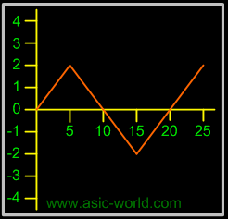

Digital Representation

Systems which process discrete values are called digital systems. In digital representation the quantities are represented not by proportional quantities but by symbols called digits. As an example, consider the digital watch, which provides the time of the day in the form of decimal digits representing hours and minutes (and sometimes seconds). As we know, time of day changes continuously, but the digital watch reading does not change continuously; rather, it changes in steps of one per minute (or per second). In other words, time of day digital representation changes in discrete steps, as compared to the representation of time provided by an analog watch, where the dial reading changes continuously.
Below is a diagram of digital voltage vs time: here input voltage changes from +4 Volts to -4 Volts; it can be converted to digital form by Analog to Digital converters (ADC). An ADC converts continuous signals into samples per second. Well, this is an entirely different theory.

Diagram of Digital voltage vs time

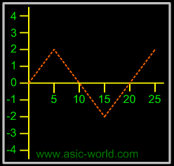

The major difference between analog and digital quantities, then, can be stated simply as follows:
- Analog = continuous
- Digital = discrete (step by step)

Advantages of Digital Techniques
- Easier to design. Exact values of voltage or current are not important, only the range (HIGH or LOW) in which they fall.
- Information storage is easy.
- Accuracy and precision are greater.
- Operations can be programmed. Analog systems can also be programmed, but the available operations variety and complexity is severely limited.
- Digital circuits are less affected by noise; as long as the noise is not large enough to prevent us from distinguishing HIGH from LOW (we discuss this in detail in an advanced digital tutorial section).
- More digital circuitry can be fabricated on IC chips.

Limitations of Digital Techniques
- Most physical quantities in real world are analog in nature, and these quantities are often the inputs and outputs that are being monitored, operated on, and controlled by a system. Thus conversion to digital format and re-conversion to analog format is needed.

Numbering System

- Decimal System
Decimal Examples
- Binary System
Binary Counting
Representing Binary Quantities
Typical Voltage Assignment
- Octal System
Octal to Decimal Conversion
- Hexadecimal System
Hexadecimal to Decimal Conversion

Code Conversion
- Binary-To-Decimal Conversion
- Decimal-To-Binary Conversion
  - Reverse of Binary-To-Decimal Method
  - Repeat Division-Convert decimal to binary
- Binary-To-Octal / Octal-To-Binary Conversion
  - Repeat Division-Convert decimal to octal
- Hexadecimal to Decimal/Decimal to Hexadecimal Conversion
  - Repeat Division- Convert decimal to hexadecimal
- Binary-To-Hexadecimal /Hexadecimal-To-Binary Conversion
- Octal-To-Hexadecimal Hexadecimal-To-Octal Conversion

Binary Codes
- Weighted Binary Systems
    - 8421 Code/BCD Code
    - 2421 Code
    - 5211 Code
    - Reflective Code
    - Sequential Codes
    - Non Weighted Codes
    - Excess-3 Code
    - Gray Code
Error Detecting and Correction Codes

- Error Detecting Codes
  - Parity
  - Check Sums
- Error-Correcting Codes
  - Hamming Code
- Alphanumeric Codes
  - ASCII Code
  - EBCDIC Code
Floating Point Numbers
- Binary Representation of Floating Point Numbers
  - Example

Numbering System
Many number systems are in use in digital technology. The most common are the decimal, binary, octal, and hexadecimal systems. The decimal system is clearly the most familiar to us because it is a tool that we use every day. Examining some of its characteristics will help us to better understand the other systems. In the next few pages we shall introduce four numerical representation systems that are used in the digital system. There are other systems, which we will look at briefly.
- Decimal
- Binary
- Octal
- Hexadecimal
Decimal System
The decimal system is composed of 10 numerals or symbols. These 10 symbols are 0, 1, 2, 3, 4, 5, 6, 7, 8, 9. Using these symbols as digits of a number, we can express any quantity. The decimal system is also called the base-10 system because it has 10 digits.
10³ | 10² | 10¹ | 10⁰ |  | 10⁻¹ | 10⁻² | 10⁻³
=1000 | =100 | =10 | =1 | . | =0.1 | =0.01 | =0.001
Most Significant Digit |  |  |  | Decimal point |  |  | Least Significant Digit
Even though the decimal system has only 10 symbols, any number of any magnitude can be expressed by using our system of positional weighting.
Decimal Examples
- 3.14₁₀
- 52₁₀
- 1024₁₀
- 64000₁₀
Binary System
In the binary system, there are only two symbols or possible digit values, 0 and 1. This base-2 system can be used to represent any quantity that can be represented in decimal or other base system.

2³ | 2² | 2¹ | 2⁰ |  | 2⁻¹ | 2⁻² | 2⁻³
=8 | =4 | =2 | =1 | . | =0.5 | =0.25 | =0.125
Most Significant Digit |  |  |  | Binary point |  |  | Least Significant Digit

Binary Counting
The Binary counting sequence is shown in the table:

2³ | 2² | 2¹ | 2⁰ | Decimal
0 | 0 | 0 | 0 | 0
0 | 0 | 0 | 1 | 1
0 | 0 | 1 | 0 | 2
0 | 0 | 1 | 1 | 3
0 | 1 | 0 | 0 | 4
0 | 1 | 0 | 1 | 5
0 | 1 | 1 | 0 | 6
0 | 1 | 1 | 1 | 7
1 | 0 | 0 | 0 | 8
1 | 0 | 0 | 1 | 9
1 | 0 | 1 | 0 | 10
1 | 0 | 1 | 1 | 11
1 | 1 | 0 | 0 | 12
1 | 1 | 0 | 1 | 13
1 | 1 | 1 | 0 | 14
1 | 1 | 1 | 1 | 15

Representing Binary Quantities
In digital systems the information that is being processed is usually presented in binary form. Binary quantities can be represented by any device that has only two operating states or possible conditions. E.g.. a switch is only open or closed. We arbitrarily (as we define them) let an open switch represent binary 0 and a closed switch represent binary 1. Thus we can represent any binary number by using series of switches.

Typical Voltage Assignment
Binary 1: Any voltage between 2V to 5V
Binary 0: Any voltage between 0V to 0.8V
Not used: Voltage between 0.8V to 2V in 5 Volt CMOS and TTL Logic, this may cause error in a digital circuit. Today's digital circuits works at 1.8 volts, so this statement may not hold true for all logic circuits.
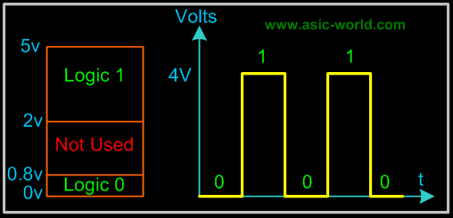
We can see another significant difference between digital and analog systems. In digital systems, the exact voltage value is not important; eg, a voltage of 3.6V means the same as a voltage of 4.3V. In analog systems, the exact voltage value is important.
The binary number system is the most important one in digital systems, but several others are also important. The decimal system is important because it is universally used to represent quantities outside a digital system. This means that there will be situations where decimal values have to be converted to binary values before they are entered into the digital system.
In additional to binary and decimal, two other number systems find wide-spread applications in digital systems. The octal (base-8) and hexadecimal (base-16) number systems are both used for the same purpose- to provide an efficient means for representing large binary system.

Octal System
The octal number system has a base of eight, meaning that it has eight possible digits: 0,1,2,3,4,5,6,7.

8³ | 8² | 8¹ | 8⁰ |  | 8⁻¹ | 8⁻² | 8⁻³
=512 | =64 | =8 | =1 | . | =1/8 | =1/64 | =1/512
Most Significant Digit |  |  |  | Octal point |  |  | Least Significant Digit

Octal to Decimal Conversion
- 237₈ = 2 x (8²) + 3 x (8¹) + 7 x (8⁰) = 159₁₀
- 24.6₈ = 2 x (8¹) + 4 x (8⁰) + 6 x (8⁻¹) = 20.75₁₀
- 11.1₈ = 1 x (8¹) + 1 x (8⁰) + 1 x (8⁻¹) = 9.125₁₀
- 12.3₈ = 1 x (8¹) + 2 x (8⁰) + 3 x (8⁻¹) = 10.375₁₀

Hexadecimal System
The hexadecimal system uses base 16. Thus, it has 16 possible digit symbols. It uses the digits 0 through 9 plus the letters A, B, C, D, E, and F as the 16 digit symbols.

16³ | 16² | 16¹ | 16⁰ |  | 16⁻¹ | 16⁻² | 16⁻³
=4096 | =256 | =16 | =1 | . | =1/16 | =1/256 | =1/4096
Most Significant Digit |  |  |  | Hexa Decimal point |  |  | Least Significant Digit

Hexadecimal to Decimal Conversion

- 24.616 = 2 x (161) + 4 x (160) + 6 x (16-1) = 36.37510
- 11.116 = 1 x (161) + 1 x (160) + 1 x (16-1) = 17.062510
- 12.316 = 1 x (161) + 2 x (160) + 3 x (16-1) = 18.187510

Code Conversion
Converting from one code form to another code form is called code conversion, like converting from binary to decimal or converting from hexadecimal to decimal.

Binary-To-Decimal Conversion
Any binary number can be converted to its decimal equivalent simply by summing together the weights of the various positions in the binary number which contain a 1.

Binary | Decimal
11011₂
2⁴+2³+0¹+2¹+2⁰ | =16+8+0+2+1
Result | 27₁₀

And
Binary | Decimal
10110101₂
2⁷+0⁶+2⁵+2⁴+0³+2²+0¹+2⁰ | =128+0+32+16+0+4+0+1
Result | 181₁₀
You should have noticed that the method is to find the weights (i.e., powers of 2) for each bit position that contains a 1, and then to add them up.

Decimal-To-Binary Conversion
There are 2 methods:
- Reverse of Binary-To-Decimal Method
- Repeat Division
Reverse of Binary-To-Decimal Method
Decimal | Binary
45₁₀ | =32 + 0 + 8 + 4 +0 + 1
 | =2⁵+0+2³+2²+0+2⁰
Result | =101101₂
Repeat Division-Convert decimal to binary
This method uses repeated division by 2.
Convert 25₁₀ to binary

Division | Remainder | Binary
25/2 | = 12+ remainder of 1 | 1 (Least Significant Bit)
12/2 | = 6 + remainder of 0 | 0
6/2 | = 3 + remainder of 0 | 0
3/2 | = 1 + remainder of 1 | 1
1/2 | = 0 + remainder of 1 | 1 (Most Significant Bit)
Result | 25₁₀ | = 11001₂

The Flow chart for repeated-division method is as follows:
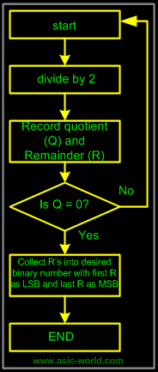
Binary-To-Octal / Octal-To-Binary Conversion
Octal Digit | 0 | 1 | 2 | 3 | 4 | 5 | 6 | 7
Binary Equivalent | 000 | 001 | 010 | 011 | 100 | 101 | 110 | 111

Each Octal digit is represented by three binary digits.
Example:
100 111 0102 = (100) (111) (010)2 = 4 7 28

Repeat Division-Convert decimal to octal
This method uses repeated division by 8.
Example: Convert 17710 to octal and binary.

Division | Result | Binary
177/8 | = 22+ remainder of 1 | 1 (Least Significant Bit)
22/ 8 | = 2 + remainder of 6 | 6
2 / 8 | = 0 + remainder of 2 | 2 (Most Significant Bit)
Result | 177₁₀ | = 261₈
Binary |  | = 010110001₂

Hexadecimal to Decimal/Decimal to Hexadecimal Conversion
Example:
2AF₁₆ = 2 x (16²) + 10 x (16¹) + 15 x (16⁰) = 687₁₀

Repeat Division- Convert decimal to hexadecimal
This method uses repeated division by 16.
Example: convert 378₁₀ to hexadecimal and binary:

Division | Result | Hexadecimal
378/16 | = 23+ remainder of 10 | A (Least Significant Bit)23
23/16 | = 1 + remainder of 7 | 7
1/16 | = 0 + remainder of 1 | 1 (Most Significant Bit)
Result | 378₁₀ | = 17A₁₆
Binary |  | = 0001 0111 1010₂

Binary-To-Hexadecimal /Hexadecimal-To-Binary Conversion

Hexadecimal Digit | 0 | 1 | 2 | 3 | 4 | 5 | 6 | 7
Binary Equivalent | 0000 | 0001 | 0010 | 0011 | 0100 | 0101 | 0110 | 0111

Hexadecimal Digit | 8 | 9 | A | B | C | D | E | F
Binary Equivalent | 1000 | 1001 | 1010 | 1011 | 1100 | 1101 | 1110 | 1111

Each Hexadecimal digit is represented by four bits of binary digit.
Example:
1011 0010 1111₂ = (1011) (0010) (1111)₂ = B 2 F₁₆

Octal-To-Hexadecimal Hexadecimal-To-Octal Conversion
- Convert Octal (Hexadecimal) to Binary first.
- Regroup the binary number by three bits per group starting from LSB if Octal is required.
- Regroup the binary number by four bits per group starting from LSB if Hexadecimal is required.

Example:
Convert 5A8₁₆ to Octal.

Hexadecimal | Binary/Octal
5A816 | = 0101 1010 1000 (Binary)
 | = 010 110 101 000 (Binary)
Result | = 2 6 5 0 (Octal)

Binary Codes
Binary codes are codes which are represented in binary system with modification from the original ones. Below we will be seeing the following:
- Weighted Binary Systems
- Non Weighted Codes

Weighted Binary Systems
Weighted binary codes are those which obey the positional weighting principles, each position of the number represents a specific weight. The binary counting sequence is an example.

Decimal | 8421 | 2421 | 5211 | Excess-3
0 | 0000 | 0000 | 0000 | 0011
1 | 0001 | 0001 | 0001 | 0100
2 | 0010 | 0010 | 0011 | 0101
3 | 0011 | 0011 | 0101 | 0110
4 | 0100 | 0100 | 0111 | 0111
5 | 0101 | 1011 | 1000 | 1000
6 | 0110 | 1100 | 1010 | 1001
7 | 0111 | 1101 | 1100 | 1010
8 | 1000 | 1110 | 1110 | 1011
9 | 1001 | 1111 | 1111 | 1100

8421 Code/BCD Code
The BCD (Binary Coded Decimal) is a straight assignment of the binary equivalent. It is possible to assign weights to the binary bits according to their positions. The weights in the BCD code are 8,4,2,1.
Example: The bit assignment 1001, can be seen by its weights to represent the decimal 9 because:
1x8+0x4+0x2+1x1 = 9

2421 Code
This is a weighted code, its weights are 2, 4, 2 and 1. A decimal number is represented in 4-bit form and the total four bits weight is 2 + 4 + 2 + 1 = 9. Hence the 2421 code represents the decimal numbers from 0 to 9.

5211 Code
This is a weighted code, its weights are 5, 2, 1 and 1. A decimal number is represented in 4-bit form and the total four bits weight is 5 + 2 + 1 + 1 = 9. Hence the 5211 code represents the decimal numbers from 0 to 9.

Reflective Code
A code is said to be reflective when code for 9 is complement for the code for 0, and so is for 8 and 1 codes, 7 and 2, 6 and 3, 5 and 4. Codes 2421, 5211, and excess-3 are reflective, whereas the 8421 code is not.

Sequential Codes
A code is said to be sequential when two subsequent codes, seen as numbers in binary representation, differ by one. This greatly aids mathematical manipulation of data. The 8421 and Excess-3 codes are sequential, whereas the 2421 and 5211 codes are not.

Non Weighted Codes

Non weighted codes are codes that are not positionally weighted. That is, each position within the binary number is not assigned a fixed value.

Excess-3 Code
Excess-3 is a non weighted code used to express decimal numbers. The code derives its name from the fact that each binary code is the corresponding 8421 code plus 0011(3).
Example: 1000 of 8421 = 1011 in Excess-3

Gray Code
The gray code belongs to a class of codes called minimum change codes, in which only one bit in the code changes when moving from one code to the next. The Gray code is non-weighted code, as the position of bit does not contain any weight. The gray code is a reflective digital code which has the special property that any two subsequent numbers codes differ by only one bit. This is also called a unit-distance code. In digital Gray code has got a special place.

Decimal Number | Binary Code | Gray Code
0 | 0000 | 0000
1 | 0001 | 0001
2 | 0010 | 0011
3 | 0011 | 0010
4 | 0100 | 0110
5 | 0101 | 0111
6 | 0110 | 0101
7 | 0111 | 0100
8 | 1000 | 1100
9 | 1001 | 1101
10 | 1010 | 1111
11 | 1011 | 1110
12 | 1100 | 1010
13 | 1101 | 1011
14 | 1110 | 1001
15 | 1111 | 1000

Binary to Gray Conversion
- Gray Code MSB is binary code MSB.
- Gray Code MSB-1 is the XOR of binary code MSB and MSB-1.
- MSB-2 bit of gray code is XOR of MSB-1 and MSB-2 bit of binary code.
- MSB-N bit of gray code is XOR of MSB-N-1 and MSB-N bit of binary code.

Error Detecting and Correction Codes
For reliable transmission and storage of digital data, error detection and correction is required. Below are a few examples of codes which permit error detection and error correction after detection.

Error Detecting Codes
When data is transmitted from one point to another, like in wireless transmission, or it is just stored, like in hard disks and memories, there are chances that data may get corrupted. To detect these data errors, we use special codes, which are error detection codes.

Parity
In parity codes, every data byte, or nibble (according to how user wants to use it) is checked if they have even number of ones or even number of zeros. Based on this information an additional bit is appended to the original data. Thus if we consider 8-bit data, adding the parity bit will make it 9 bit long.
At the receiver side, once again parity is calculated and matched with the received parity (bit 9), and if they match, data is ok, otherwise data is corrupt.

There are two types of parity:
- Even parity: Checks if there is an even number of ones; if so, parity bit is zero. When the number of ones is odd then parity bit is set to 1.
- Odd Parity: Checks if there is an odd number of ones; if so, parity bit is zero. When number of ones is even then parity bit is set to 1.

Check Sums
The parity method is calculated over byte, word or double word. But when errors need to be checked over 128 bytes or more (basically blocks of data), then calculating parity is not the right way. So we have checksum, which allows to check for errors on block of data. There are many variations of checksum.
- Adding all bytes
- CRC
- Fletcher's checksum
- Adler-32
The simplest form of checksum, which simply adds up the asserted bits in the data, cannot detect a number of types of errors. In particular, such a checksum is not changed by:
- Reordering of the bytes in the message
- Inserting or deleting zero-valued bytes
Multiple errors which sum to zero

Example of Checksum : Given 4 bytes of data (can be done with any number of bytes): 25h, 62h, 3Fh, 52h
- Adding all bytes together gives 118h.
- Drop the Carry Nibble to give you 18h.
Get the two's complement of the 18h to get E8h. This is the checksum byte.

To Test the Checksum byte simply add it to the original group of bytes. This should give you 200h.
Drop the carry nibble again giving 00h. Since it is 00h this means the checksum means the bytes were probably not changed.

Error-Correcting Codes

Error-correcting codes not only detect errors, but also correct them. This is used normally in Satellite communication, where turn-around delay is very high as is the probability of data getting corrupt.
ECC (Error correcting codes) are used also in memories, networking, Hard disk, CDROM, DVD etc.
Normally in networking chips (ASIC), we have 2 Error detection bits and 1 Error correction bit.

Hamming Code

Hamming code adds a minimum number of bits to the data transmitted in a noisy channel, to be able to correct every possible one-bit error. It can detect (not correct) two-bits errors and cannot distinguish between 1-bit and 2-bits inconsistencies. It can't - in general - detect 3(or more)-bits errors.
The idea is that the failed bit position in an n-bit string (which we'll call X) can be represented in binary with log₂(n) bits, hence we'll try to get it adding just log₂(n) bits.
First, we set m = n + log₂(n) to the encoded string length and we number each bit position starting from 1 through m. Then we place these additional bits at power-of-two positions, that is 1, 2, 4, 8..., while remaining ones (3, 5, 6, 7...) hold the bit string in the original order.

Now we set each added bit to the parity of a group of bits. We group bits this way: we form a group for every parity bit, where the following relation holds:
position(bit) AND position(parity) = position(parity)
(Note that: AND is the bit-wise boolean AND; parity bits are included in the groups; each bit can belong to one or more groups.)

So bit 1 groups bits 1, 3, 5, 7... while bit 2 groups bits 2, 3, 6, 7, 10... , bit 4 groups bits 4, 5, 6, 7, 12, 13... and so on.
Thus, by definition, X (the failed bit position defined above) is the sum of the incorrect parity bits positions (0 for no errors).
To understand why it is so, let's call X_{n} the n^{th} bit of X in binary representation. Now consider that each parity bit is tied to a bit of X: parity1 -> X₁, parity2 -> X₂, parity4 -> X₃, parity8 -> X₄ and so on - for programmers: they are the respective AND masks -. By construction, the failed bit makes fail only the parity bits which correspond to the 1s in X, so each bit of X is 1 if the corresponding parity is wrong and 0 if it is correct.

Note that the longer the string, the higher the throughput n/m and the lower the probability that no more than one bit fails. So the string to be sent should be broken into blocks whose length depends on the transmission channel quality (the cleaner the channel, the bigger the block). Also, unless it's guaranteed that at most one bit per block fails, a checksum or some other form of data integrity check should be added.

Alphanumeric Codes
The binary codes that can be used to represent all the letters of the alphabet, numbers and mathematical symbols, punctuation marks, are known as alphanumeric codes or character codes. These codes enable us to interface the input-output devices like the keyboard, printers, video displays with the computer.

ASCII Code
ASCII stands for American Standard Code for Information Interchange. It has become a world standard alphanumeric code for microcomputers and computers. It is a 7-bit code representing 2⁷ = 128 different characters. These characters represent 26 upper case letters (A to Z), 26 lowercase letters (a to z), 10 numbers (0 to 9), 33 special characters and symbols and 33 control characters.
The 7-bit code is divided into two portions, The leftmost 3 bits portion is called zone bits and the 4-bit portion on the right is called numeric bits.
An 8-bit version of ASCII code is known as USACC-II 8 or ASCII-8. The 8-bit version can represent a maximum of 256 characters.

EBCDIC Code
EBCDIC stands for Extended Binary Coded Decimal Interchange. It is mainly used with large computer systems like mainframes. EBCDIC is an 8-bit code and thus accomodates up to 256 characters. An EBCDIC code is divided into two portions: 4 zone bits (on the left) and 4 numeric bits (on the right).

Floating Point Numbers
A real number or floating point number is a number which has both an integer and a fractional part. Examples for real real decimal numbers are 123.45, 0.1234, -0.12345, etc. Examples for real binary numbers are 1100.1100, 0.1001, -1.001, etc. In general, floating point numbers are expressed in exponential notation.

For example the decimal number
- 30000.0 can be written as 3 x 10⁴.
- 312.45 can be written as 3.1245 x 10².

Similarly, the binary number 1010.001 can be written as 1.010001 x 10³.
The general form of a number N can be expressed as
N = ± m x b^{±e}.
Where m is mantissa, b is the base of number system and e is the exponent. A floating point number is represented by two parts. The number first part, called mantissa, is a signed fixed point number and the second part, called exponent, specifies the decimal or binary position.

Binary Representation of Floating Point Numbers
A floating point binary number is also represented as in the case of decimal numbers. It means that mantissa and exponent are expressed using signed magnitude notation in which one bit is reserved for sign bit.
Consider a 16-bit word used to store the floating point numbers; assume that 9 bits are reserved for mantissa and 7 bits for exponent and also assume that the mantissa part is represented in fraction system. This implies the assumed binary point is at the mantissa sign bit immediate right.

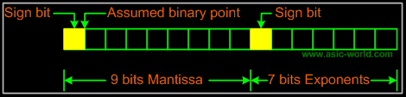

Example
A binary number 1101.01 is represented as
Mantissa = 110101 = (1101.01)₂ = 0.110101 X 2⁴
Exponent = (4)₁₀
Expanding mantissa to 8 bits we get 11010100
Binary representation of exponent (4)₁₀ = 000100
The required representation is

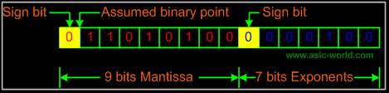

- Symbolic Logic
  - Precedence
  - Function Definitions
  - Truth Tables
  - Boolean Switching Algebra
    - Axioms
    - Closure
    - Identity
    - Commutative Laws
    - Distributive Laws
    - Complement
    - Theorems
      - Idempotent Law
      - DeMorgan's Law
      - Boundedness Law
      - Absorption Law
      - Elimination Law
    - Unique Complement theorem
    - Involution theorem
    - Associative Properties
    - Duality Principle
    - Consensus theorem
    - Shannon Expansion Theorem
    - Summary of Laws And Theorems
    - Algebraic Manipulation
      - Minterms and Maxterms
        - Sum Of Products (SOP)
        - Product Of Sum (POS)
        - Exercise
      - Conversion between POS and SOP
        - Simplification
    - Logic Circuits
      - Fixed Logic Systems
        - Positive Logic
        - Negative Logic
      - Switching Circuits
        - Two variable AND circuit X.Y
        - Two variable OR circuit X + Y
        - Four variable circuit U.V.(X + Y)
      - Truth Table

Symbolic Logic
Boolean algebra derives its name from the mathematician George Boole. Symbolic Logic uses values, variables and operations:
- True is represented by the value 1.
- False is represented by the value 0.

Variables are represented by letters and can have one of two values, either 0 or 1. Operations are functions of one or more variables.
- AND is represented by X.Y
- OR is represented by X + Y
- NOT is represented by X' .
Throughout this tutorial the X' form will be used and sometime !X will be used.
These basic operations can be combined to give expressions.
Example :
- X
- X.Y
- W.X.Y + Z

Precedence
As with any other branch of mathematics, these operators have an order of precedence. NOT operations have the highest precedence, followed by AND operations, followed by OR operations. Brackets can be used as with other forms of algebra. e.g.
X.Y + Z and X.(Y + Z) are not the same function.

Function Definitions
The logic operations given previously are defined as follows :
Define f(X,Y) to be some function of the variables X and Y.
f(X,Y) = X.Y
- 1 if X = 1 and Y = 1
- 0 Otherwise
f(X,Y) = X + Y
- 1 if X = 1 or Y = 1
- 0 Otherwise
f(X) = X'
- 1 if X = 0
- 0 Otherwise

Truth Tables
Truth tables are a means of representing the results of a logic function using a table. They are constructed by defining all possible combinations of the inputs to a function, and then calculating the output for each combination in turn. For the three functions we have just defined, the truth tables are as follows.

AND
X | Y | F(X,Y)
0 | 0 | 0
0 | 1 | 0
1 | 0 | 0
1 | 1 | 1

OR
X | Y | F(X,Y)
0 | 0 | 0
0 | 1 | 1
1 | 0 | 1
1 | 1 | 1

NOT
X | F(X)
0 | 1
1 | 0

Truth tables may contain as many input variables as desired

F(X,Y,Z) = X.Y + Z
X | Y | Z | F(X,Y,Z)
0 | 0 | 0 | 0
0 | 0 | 1 | 1
0 | 1 | 0 | 0
0 | 1 | 1 | 1
1 | 0 | 0 | 0
1 | 0 | 1 | 1
1 | 1 | 0 | 1
1 | 1 | 1 | 1

Boolean Switching Algebras
A Boolean Switching Algebra is one which deals only with two-valued variables. Boole's general theory covers algebras which deal with variables which can hold n values.

Axioms
Consider a set S = { 0. 1}
Consider two binary operations, + and . , and one unary operation, -- , that act on these elements. [S, ., +, --, 0, 1] is called a switching algebra that satisfies the following axioms S

Closure
If X S and Y S then X.Y S
If X S and Y S then X+Y S

Identity
- an identity 0 for + such that X + 0 = X
- an identity 1 for . such that X . 1 = X

Commutative Laws
- X + Y = Y + X
- X . Y = Y . X

Distributive Laws
- X.(Y + Z ) = X.Y + X.Z
- X + Y.Z = (X + Y) . (X + Z)

Complement
X S a complement X'such that
X + X' = 1
X . X' = 0
The complement X' is unique.

Theorems
A number of theorems may be proved for switching algebras

Idempotent Law
X + X = X
X . X = X

DeMorgan's Law
(X + Y)' = X' . Y', These can be proved by the use of truth tables.
Proof of (X + Y)' = X' . Y'

X | Y | X+Y | (X+Y)'
0 | 0 | 0 | 1
0 | 1 | 1 | 0
1 | 0 | 1 | 0
1 | 1 | 1 | 0

X | Y | X' | Y' | X'.Y'
0 | 0 | 1 | 1 | 1
0 | 1 | 1 | 0 | 0
1 | 0 | 0 | 1 | 0
1 | 1 | 0 | 0 | 0

The two truth tables are identical, and so the two expressions are identical.
(X.Y) = X' + Y', These can be proved by the use of truth tables.
Proof of (X.Y) = X' + Y'

X | Y | X.Y | (X.Y)'
0 | 0 | 0 | 1
0 | 1 | 0 | 1
1 | 0 | 0 | 1
1 | 1 | 1 | 0

X | Y | X' | Y' | X'+Y'
0 | 0 | 1 | 1 | 1
0 | 1 | 1 | 0 | 1
1 | 0 | 0 | 1 | 1
1 | 1 | 0 | 0 | 0

Note : DeMorgans Laws are applicable for any number of variables.

Boundedness Law
X + 1 = 1
X . 0 = 0

Absorption Law
X + (X . Y) = X
X . (X + Y ) = X

Elimination Law
X + (X' . Y) = X + Y
X.(X' + Y) = X.Y

Unique Complement theorem
If X + Y = 1 and X.Y = 0 then X = Y'

Involution theorem
X'' = X
0' = 1

Associative Properties
X + (Y + Z) = (X + Y) + Z
X . ( Y . Z ) = ( X . Y ) . Z

Duality Principle
In Boolean algebras the duality Principle can be is obtained by interchanging AND and OR operators and replacing 0's by 1's and 1's by 0's. Compare the identities on the left side with the identities on the right.
Example
X.Y+Z' = (X'+Y').Z

Consensus theorem
X.Y + X'.Z + Y.Z = X.Y + X'.Z
or dual form as below
(X + Y).(X' + Z).(Y + Z) = (X + Y).(X' + Z)
Proof of X.Y + X'.Z + Y.Z = X.Y + X'.Z:

X.Y + X'.Z + Y.Z | = X.Y + X'.Z
X.Y + X'.Z + (X+X').Y.Z | = X.Y + X'.Z
X.Y.(1+Z) + X'.Z.(1+Y) | = X.Y + X'.Z
X.Y + X'.Z | = X.Y + X'.Z

(X.Y'+Z).(X+Y).Z = X.Z+Y.Z instead of X.Z+Y'.Z
X.Y'Z+X.Z+Y.Z
(X.Y'+X+Y).Z
(X+Y).Z
X.Z+Y.Z
The term which is left out is called the consensus term.
Given a pair of terms for which a variable appears in one term, and its complement in the other, then the consensus term is formed by ANDing the original terms together, leaving out the selected variable and its complement.
Example :
The consensus of X.Y and X'.Z is Y.Z
The consensus of X.Y.Z and Y'.Z'.W' is (X.Z).(Z.W')

Shannon Expansion Theorem
The Shannon Expansion Theorem is used to expand a Boolean logic function (F) in terms of (or with respect to) a Boolean variable (X), as in the following forms.
F = X . F (X = 1) + X' . F (X = 0)
where F (X = 1) represents the function F evaluated with X set equal to 1; F (X = 0) represents the function F evaluated with X set equal to 0.
Also the following function F can be expanded with respect to X,
F = X' . Y + X . Y . Z' + X' . Y' . Z
= X . (Y . Z') + X' . (Y + Y' . Z)
Thus, the function F can be split into two smaller functions.
F (X = '1') = Y . Z'
This is known as the cofactor of F with respect to X in the previous logic equation. The cofactor of F with respect to X may also be represented as F X (the cofactor of F with respect to X' is F X' ). Using the Shannon Expansion Theorem, a Boolean function may be expanded with respect to any of its variables. For example, if we expand F with respect to Y instead of X,
F = X' . Y + X . Y . Z' + X' . Y' . Z
= Y . (X' + X . Z') + Y' . (X' . Z)
A function may be expanded as many times as the number of variables it contains until the canonical form is reached. The canonical form is a unique representation for any Boolean function that uses only minterms. A minterm is a product term that contains all the variables of F¿such as X . Y' . Z).
Any Boolean function can be implemented using multiplexer blocks by representing it as a series of terms derived using the Shannon Expansion Theorem.

Summary of Laws And Theorms
Identity | Dual
Operations with 0 and 1
X + 0 = X (identity) | X.1 = X
X + 1 = 1 (null element) | X.0 = 0
Idempotency theorem
X + X = X | X.X = X
Complementarity
X + X' = 1 | X.X' = 0
Involution theorem
(X')' = X
Cummutative law
X + Y = Y + X | X.Y = Y X
Associative law
(X + Y) + Z = X + (Y + Z) = X + Y + Z | (XY)Z = X(YZ) = XYZ
Distributive law
X(Y + Z) = XY + XZ | X + (YZ) = (X + Y)(X + Z)
DeMorgan's theorem
(X + Y + Z + ...)' = X'Y'Z'... or { f ( X1,X2,...,Xn,0,1,+,. ) } = { f ( X1',X2',...,Xn',1,0,.,+ ) } | (XYZ...)' = X' + Y' + Z' + ...
Simplification theorems
XY + XY' = X (uniting) | (X + Y)(X + Y') = X
X + XY = X (absorption) | X(X + Y) = X
(X + Y')Y = XY (adsorption) | XY' + Y = X + Y
Consensus theorem
XY + X'Z + YZ = XY + X'Z | (X + Y)(X' + Z)(Y + Z) = (X + Y)(X' + Z)
Duality
(X + Y + Z + ...)^{D} = XYZ... or {f(X1,X2,...,Xn,0,1,+,.)}^{D} = f(X1,X2,...,Xn,1,0,.,+) | (XYZ ...)^{D} = X + Y + Z + ...
Shannon Expansion Theorem
f(X₁,...,X_{k},...X_{n}) | X_{k} * f(X₁,..., 1 ,...X_{n}) + X_{k}' * f(X₁,..., 0 ,...X_{n})
f(X₁,...,X_{k},...X_{n}) | [X_{k} + f(X₁,..., 0 ,...X_{n})] * [X_{k}' + f(X₁,..., 1 ,...X_{n})]

Algebraic Manipulation

Minterms and Maxterms:

Any boolean expression may be expressed in terms of either minterms or maxterms. To do this we must first define the concept of a literal. A literal is a single variable within a term which may or may not be complemented. For an expression with N variables, minterms and maxterms are defined as follows :
- A minterm is the product of N distinct literals where each literal occurs exactly once.
- A maxterm is the sum of N distinct literals where each literal occurs exactly once.
For a two-variable expression, the minterms and maxterms are as follows

X | Y | Minterm | Maxterm
0 | 0 | X'.Y' | X+Y
0 | 1 | X'.Y | X+Y'
1 | 0 | X.Y' | X'+Y
1 | 1 | X.Y | X'+Y'

For a three-variable expression, the minterms and maxterms are as follows

X | Y | Z | Minterm | Maxterm
0 | 0 | 0 | X'.Y'.Z' | X+Y+Z
0 | 0 | 1 | X'.Y'.Z | X+Y+Z'
0 | 1 | 0 | X'.Y.Z' | X+Y'+Z
0 | 1 | 1 | X'.Y.Z | X+Y'+Z'
1 | 0 | 0 | X.Y'.Z' | X'+Y+Z
1 | 0 | 1 | X.Y'.Z | X'+Y+Z'
1 | 1 | 0 | X.Y.Z' | X'+Y'+Z
1 | 1 | 1 | X.Y.Z | X'+Y'+Z'

This allows us to represent expressions in either Sum of Products or Product of Sums forms

Sum Of Products (SOP)

The Sum of Products form represents an expression as a sum of minterms.
F(X, Y, ...) = Sum (a_{k}.m_{k})
where a_{k} is 0 or 1 and m_{k} is a minterm.
To derive the Sum of Products form from a truth table, OR together all of the minterms which give a value of 1.

Example – SOP
Consider the truth table

X | Y | F | Minterm
0 | 0 | 0 | X'.Y'
0 | 1 | 0 | X'Y
1 | 0 | 1 | X.Y'
1 | 1 | 1 | X.Y

Here SOP is f(X.Y) = X.Y' + X.Y

Product Of Sum (POS)
The Product of Sums form represents an expression as a product of maxterms.
F(X, Y, .......) = Product (b_{k} + M_{k}), where b_{k} is 0 or 1 and M_{k} is a maxterm.
To derive the Product of Sums form from a truth table, AND together all of the maxterms which give a value of 0.

Example – POS

Consider the truth table from the previous example.

X | Y | F | Maxterm
0 | 0 | 1 | X+Y
0 | 1 | 0 | X+Y'
1 | 0 | 1 | X'+Y
1 | 1 | 1 | X'+Y'

Here POS is F(X,Y) = (X+Y')

Exercise
Give the expression represented by the following truth table in both Sum of Products and Product of Sums forms.

X | Y | Z | F(X,Y,X)
0 | 0 | 0 | 1
0 | 0 | 1 | 0
0 | 1 | 0 | 0
0 | 1 | 1 | 1
1 | 0 | 0 | 0
1 | 0 | 1 | 1
1 | 1 | 0 | 1
1 | 1 | 1 | 0

Conversion between POS and SOP
Conversion between the two forms is done by application of DeMorgans Laws.

Simplification
As with any other form of algebra you have encountered, simplification of expressions can be performed with Boolean algebra.

Example
Show that X.Y.Z' + X'.Y.Z' + Y.Z = Y
X.Y.Z' + X'.Y.Z' + Y.Z = Y.Z' + Y.Z = Y

Example
Show that (X.Y' + Z).(X + Y).Z = X.Z + Y.Z
(X.Y' + Z).(X + Y).Z
= (X.Y' + Z.X + Y'.Z).Z
= X.Y'Z + Z.X + Y'.Z
= Z.(X.Y' + X + Y')
= Z.(X+Y')

Logic Circuits
Boolean algebra is ideal for expressing the behavior of logic circuits.
A circuit can be expressed as a logic design and implemented as a collection of individual connected logic gates.

Fixed Logic Systems
A fixed logic system has two possible choices for representing true and false.

Positive Logic
In a positive logic system, a high voltage is used to represent logical true (1), and a low voltage for a logical false (0).

Negative Logic
In a negative logic system, a low voltage is used to represent logical true (1), and a high voltage for a logical false (0).
In positive logic circuits it is normal to use +5V for true and 0V for false.

Switching Circuits
The abstract logic described previously can be implemented as an actual circuit. Switches are left open for logic 0 and closed for logic 1.

Two variable AND circuit X.Y

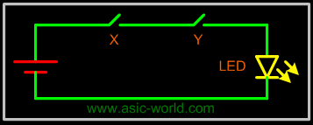

Two variable OR circuit X + Y

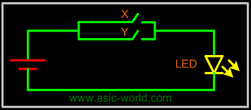

Four variable circuit U.V.(X + Y)

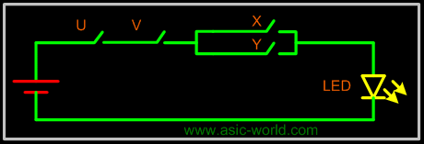

Truth Table

A truth table is a means for describing how a logic circuit's output depends on the logic levels present at the circuit's inputs.
In the following twos-inputs logic circuit, the table lists all possible combinations of logic levels present at inputs X and Y along with the corresponding output level F.

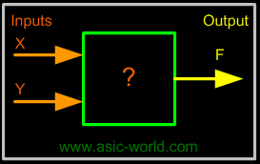

X | Y | F = X*Y
0 | 0 | 0
0 | 1 | 0
1 | 0 | 0
1 | 1 | 1

When either input X AND Y is 1, the output F is 1. Therefore the "?" in the box is an AND gate.

- Logic Gates
- Inversion
- Multiple Input Gates
- Gates Types
- AND Gate
- Switch Representation of AND Gate
- Three Input AND gate
- OR Gate
- Switch Representation of OR Gate
- Three Input OR gate
- NOT Gate
- BUF Gate
- NAND Gate
- NOR Gate
- XOR Gate
- XNOR Gate

- Universal Gates
- Realization of logic function using NAND gates
- Realization of logic gates using NAND gates
- Implementing an inverter using NAND gate
- Implementing AND using NAND gates
- Implementing OR using NAND gates
- Implementing NOR using NAND gates
- Realization of logic function using NOR gates
- Realization of logic gates using NOR gates
- Implementing an inverter using NOR gate
- Implementing AND using NOR gates
- Implementing OR using NOR gates
- Implementing NAND using NOR gates

Logic Gates

A logic gate is an electronic circuit/device which makes the logical decisions. To arrive at this decisions, the most common logic gates used are OR, AND, NOT, NAND, and NOR gates. The NAND and NOR gates are called universal gates. The exclusive-OR gate is another logic gate which can be constructed using AND, OR and NOT gate.
Logic gates have one or more inputs and only one output. The output is active only for certain input combinations. Logic gates are the building blocks of any digital circuit. Logic gates are also called switches. With the advent of integrated circuits, switches have been replaced by TTL (Transistor Transistor Logic) circuits and CMOS circuits. Here I give example circuits on how to construct simples gates.
Symbolic Logic
Boolean algebra derives its name from the mathematician George Boole. Symbolic Logic uses values, variables and operations.

Inversion
A small circle on an input or an output indicates inversion. See the NOT, NAND and NOR gates given below for examples.

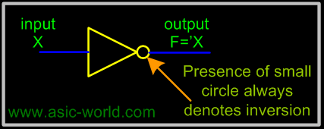

Multiple Input Gates
Given commutative and associative laws, many logic gates can be implemented with more than two inputs, and for reasons of space in circuits, usually multiple input, complex gates are made. You will encounter such gates in real world (maybe you could analyze an ASIC lib to find this).

Gates Types
- AND
- OR
- NOT
- BUF
- NAND
- NOR
- XOR
- XNOR
AND Gate
The AND gate performs logical multiplication, commonly known as AND function. The AND gate has two or more inputs and single output. The output of AND gate is HIGH only when all its inputs are HIGH (i.e. even if one input is LOW, Output will be LOW).
If X and Y are two inputs, then output F can be represented mathematically as F = X.Y, Here dot (.) denotes the AND operation. Truth table and symbol of the AND gate is shown in the figure below.

Symbol

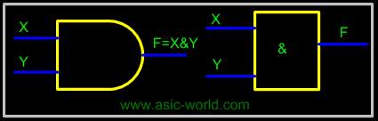

Truth Table

X | Y | F=(X.Y)
0 | 0 | 0
0 | 1 | 0
1 | 0 | 0
1 | 1 | 1

Two input AND gate using "diode-resistor" logic is shown in figure below, where X, Y are inputs and F is the output.

Circuit

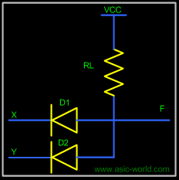

If X = 0 and Y = 0, then both diodes D1 and D2 are forward biased and thus both diodes conduct and pull F low.
If X = 0 and Y = 1, D2 is reverse biased, thus does not conduct. But D1 is forward biased, thus conducts and thus pulls F low.
If X = 1 and Y = 0, D1 is reverse biased, thus does not conduct. But D2 is forward biased, thus conducts and thus pulls F low.
If X = 1 and Y = 1, then both diodes D1 and D2 are reverse biased and thus both the diodes are in cut-off and thus there is no drop in voltage at F. Thus F is HIGH.

Switch Representation of AND Gate

In the figure below, X and Y are two switches which have been connected in series (or just cascaded) with the load LED and source battery. When both switches are closed, current flows to LED.

Three Input AND gate

Since we have already seen how a AND gate works and I will just list the truth table of a 3 input AND gate. The figure below shows its symbol and truth table.

Circuit

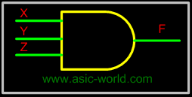

Truth Table

X | Y | Z | F=X.Y.Z
0 | 0 | 0 | 0
0 | 0 | 1 | 0
0 | 1 | 0 | 0
0 | 1 | 1 | 0
1 | 0 | 0 | 0
1 | 0 | 1 | 0
1 | 1 | 0 | 0
1 | 1 | 1 | 1

OR Gate
The OR gate performs logical addition, commonly known as OR function. The OR gate has two or more inputs and single output. The output of OR gate is HIGH only when any one of its inputs are HIGH (i.e. even if one input is HIGH, Output will be HIGH).
If X and Y are two inputs, then output F can be represented mathematically as F = X+Y. Here plus sign (+) denotes the OR operation. Truth table and symbol of the OR gate is shown in the figure below.

Symbol

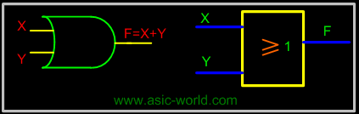

Truth Table

X | Y | F=(X+Y)
0 | 0 | 0
0 | 1 | 1
1 | 0 | 1
1 | 1 | 1
Two input OR gate using "diode-resistor" logic is shown in figure below, where X, Y are inputs and F is the output.

Circuit

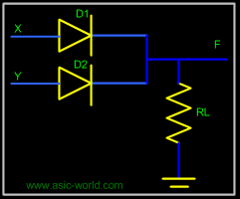

If X = 0 and Y = 0, then both diodes D1 and D2 are reverse biased and thus both the diodes are in cut-off and thus F is low.
If X = 0 and Y = 1, D1 is reverse biased, thus does not conduct. But D2 is forward biased, thus conducts and thus pulling F to HIGH.
If X = 1 and Y = 0, D2 is reverse biased, thus does not conduct. But D1 is forward biased, thus conducts and thus pulling F to HIGH.
If X = 1 and Y = 1, then both diodes D1 and D2 are forward biased and thus both the diodes conduct and thus F is HIGH.

Switch Representation of OR Gate

In the figure, X and Y are two switches which have been connected in parallel, and this is connected in series with the load LED and source battery. When both switches are open, current does not flow to LED, but when any switch is closed then current flows.

Three Input OR gate
Since we have already seen how an OR gate works, I will just list the truth table of a 3-input OR gate. The figure below shows its circuit and truth table.

Circuit

Truth Table

X | Y | Z | F=X+Y+Z
0 | 0 | 0 | 0
0 | 0 | 1 | 1
0 | 1 | 0 | 1
0 | 1 | 1 | 1
1 | 0 | 0 | 1
1 | 0 | 1 | 1
1 | 1 | 0 | 1
1 | 1 | 1 | 1

NOT Gate

The NOT gate performs the basic logical function called inversion or complementation. NOT gate is also called inverter. The purpose of this gate is to convert one logic level into the opposite logic level. It has one input and one output. When a HIGH level is applied to an inverter, a LOW level appears on its output and vice versa.
If X is the input, then output F can be represented mathematically as F = X', Here apostrophe (') denotes the NOT (inversion) operation. There are a couple of other ways to represent inversion, F= !X, here ! represents inversion. Truth table and NOT gate symbol is shown in the figure below.

Symbol

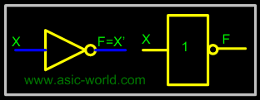

Truth Table

X | Y=X'
0 | 1
1 | 0

NOT gate using "transistor-resistor" logic is shown in the figure below, where X is the input and F is the output.

Circuit

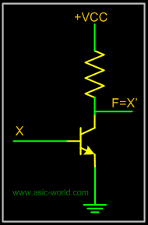
When X = 1, The transistor input pin 1 is HIGH, this produces the forward bias across the emitter base junction and so the transistor conducts. As the collector current flows, the voltage drop across RL increases and hence F is LOW.
When X = 0, the transistor input pin 2 is LOW: this produces no bias voltage across the transistor base emitter junction. Thus Voltage at F is HIGH.

BUF Gate
Buffer or BUF is also a gate with the exception that it does not perform any logical operation on its input. Buffers just pass input to output. Buffers are used to increase the drive strength or sometime just to introduce delay. We will look at this in detail later.
If X is the input, then output F can be represented mathematically as F = X. Truth table and symbol of the Buffer gate is shown in the figure below.

Symbol

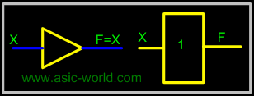

Truth Table

X | Y=X
0 | 0
1 | 1

NAND Gate
NAND gate is a cascade of AND gate and NOT gate, as shown in the figure below. It has two or more inputs and only one output. The output of NAND gate is HIGH when any one of its input is LOW (i.e. even if one input is LOW, Output will be HIGH).

NAND From AND and NOT

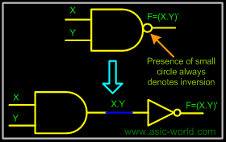

If X and Y are two inputs, then output F can be represented mathematically as F = (X.Y)', Here dot (.) denotes the AND operation and (') denotes inversion. Truth table and symbol of the N AND gate is shown in the figure below.

Symbol

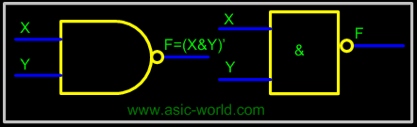

Truth Table

X | Y | F=(X.Y)'
0 | 0 | 1
0 | 1 | 1
1 | 0 | 1
1 | 1 | 0

NOR Gate
NOR gate is a cascade of OR gate and NOT gate, as shown in the figure below. It has two or more inputs and only one output. The output of NOR gate is HIGH when any all its inputs are LOW (i.e. even if one input is HIGH, output will be LOW).

Symbol

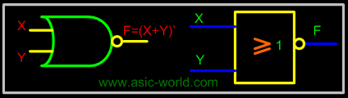

If X and Y are two inputs, then output F can be represented mathematically as F = (X+Y)'; here plus (+) denotes the OR operation and (') denotes inversion. Truth table and symbol of the NOR gate is shown in the figure below.

Truth Table

X | Y | F=(X+Y)'
0 | 0 | 1
0 | 1 | 0
1 | 0 | 0
1 | 1 | 0

XOR Gate
An Exclusive-OR (XOR) gate is gate with two or three or more inputs and one output. The output of a two-input XOR gate assumes a HIGH state if one and only one input assumes a HIGH state. This is equivalent to saying that the output is HIGH if either input X or input Y is HIGH exclusively, and LOW when both are 1 or 0 simultaneously.
If X and Y are two inputs, then output F can be represented mathematically as F = XY, Here denotes the XOR operation. XY and is equivalent to X.Y' + X'.Y. Truth table and symbol of the XOR gate is shown in the figure below.

XOR From Simple gates

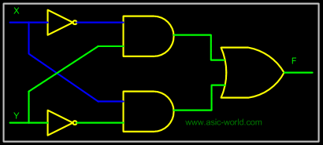

Symbol

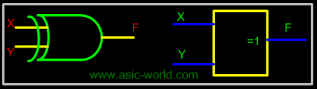

Truth Table
X | Y | F=(XY)
0 | 0 | 0
0 | 1 | 1
1 | 0 | 1
1 | 1 | 0

XNOR Gate
An Exclusive-NOR (XNOR) gate is gate with two or three or more inputs and one output. The output of a two-input XNOR gate assumes a HIGH state if all the inputs assumes same state. This is equivalent to saying that the output is HIGH if both input X and input Y is HIGH exclusively or same as input X and input Y is LOW exclusively, and LOW when both are not same.
If X and Y are two inputs, then output F can be represented mathematically as F = XY, Here denotes the XNOR operation. XY and is equivalent to X.Y + X'.Y'. Truth table and symbol of the XNOR gate is shown in the figure below.

Symbol

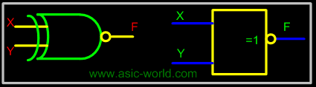
Truth Table

X | Y | F=(XY)'
0 | 0 | 1
0 | 1 | 0
1 | 0 | 0
1 | 1 | 1

Universal Gates
Universal gates are the ones which can be used for implementing any gate like AND, OR and NOT, or any combination of these basic gates; NAND and NOR gates are universal gates. But there are some rules that need to be followed when implementing NAND or NOR based gates.
To facilitate the conversion to NAND and NOR logic, we have two new graphic symbols for these gates.

NAND Gate

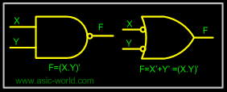

NOR Gate

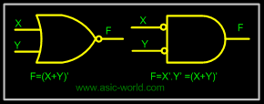

Realization of logic function using NAND gates
Any logic function can be implemented using NAND gates. To achieve this, first the logic function has to be written in Sum of Product (SOP) form. Once logic function is converted to SOP, then is very easy to implement using NAND gate. In other words any logic circuit with AND gates in first level and OR gates in second level can be converted into a NAND-NAND gate circuit.
Consider the following SOP expression
F = W.X.Y + X.Y.Z + Y.Z.W

The above expression can be implemented with three AND gates in first stage and one OR gate in second stage as shown in figure.

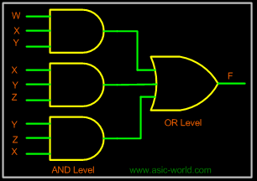
If bubbles are introduced at AND gates output and OR gates inputs (the same for NOR gates), the above circuit becomes as shown in figure.
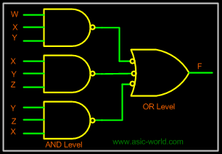
Now replace OR gate with input bubble with the NAND gate. Now we have circuit which is fully implemented with just NAND gates.
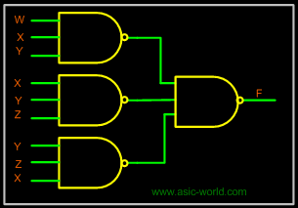

Realization of logic gates using NAND gates

Implementing an inverter using NAND gate

Input | Output | Rule
(X.X)' | = X' | Idempotent

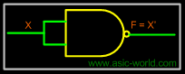

Implementing AND using NAND gates

Input | Output | Rule
((XY)'(XY)')' | = ((XY)')' | Idempotent
 | = (XY) | Involution

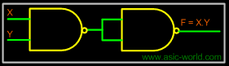

Implementing OR using NAND gates

Input | Output | Rule
((XX)'(YY)')' | = (X'Y')' | Idempotent
 | = X''+Y'' | DeMorgan
 | = X+Y | Involution

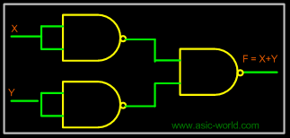

Implementing NOR using NAND gates

Input | Output | Rule
((XX)'(YY)')' | =(X'Y')' | Idempotent
 | =X''+Y'' | DeMorgan
 | =X+Y | Involution
 | =(X+Y)' | Idempotent

Realization of logic function using NOR gates

Any logic function can be implemented using NOR gates. To achieve this, first the logic function has to be written in Product of Sum (POS) form. Once it is converted to POS, then it's very easy to implement using NOR gate. In other words any logic circuit with OR gates in first level and AND gates in second level can be converted into a NOR-NOR gate circuit.
Consider the following POS expression
F = (X+Y) . (Y+Z)
The above expression can be implemented with three OR gates in first stage and one AND gate in second stage as shown in figure.

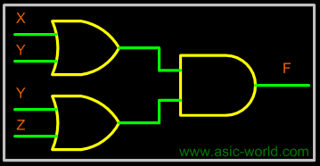

If bubble are introduced at the output of the OR gates and the inputs of AND gate, the above circuit becomes as shown in figure.

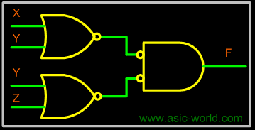

Now replace AND gate with input bubble with the NOR gate. Now we have circuit which is fully implemented with just NOR gates.
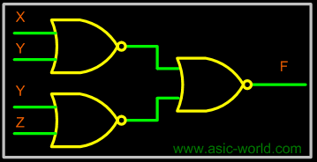
Realization of logic gates using NOR gates
Implementing an inverter using NOR gate
Input | Output | Rule
(X+X)' | = X' | Idempotent
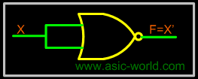
Implementing AND using NOR gates
Input | Output | Rule
((X+X)'+(Y+Y)')' | =(X'+Y')' | Idempotent
 | = X''.Y'' | DeMorgan
 | = (X.Y) | Involution
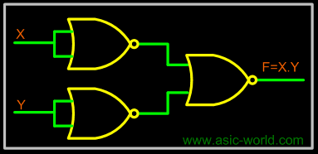
Implementing OR using NOR gates
Input
Output | Rule
((X+Y)'+(X+Y)')' | = ((X+Y)')' | Idempotent
 | = X+Y | Involution

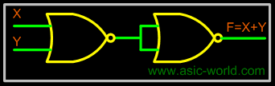

Implementing NAND using NOR gates

Input | Output | Rule
((X+Y)'+(X+Y)')' | = ((X+Y)')' | Idempotent
 | = X+Y | Involution
 | = (X+Y)' | Idempotent

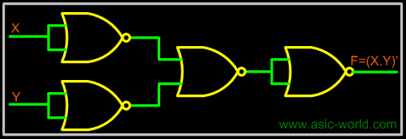

Simplification Of Boolean Functions

- Introduction
  - Minimization Technique
  - 2-Variable K-Map
    - Equivalent labeling
    - Example- Carry and Sum of a half adder
  - Grouping/Circling K-maps
    - Example of invalid groups
    - Example - X'Y+XY
    - Example - X'Y+XY+XY'
  - 3-Variable K-Map
    - Example
    - Example
  - 4-Variable K-Map
    - Example
    - Example
  - 5-Variable K-Map
  - Inverse Function
- Karnaugh Maps
- QUINE-McCLUSKEY MINIMIZATION
  - Minimization Technique
    - Example

Introduction

Simplification of Boolean functions is mainly used to reduce the gate count of a design. Less number of gates means less power consumption, sometimes the circuit works faster and also when number of gates is reduced, cost also comes down.
There are many ways to simplify a logic design, some of them are given below. We will be looking at each of these in detail in the next few pages.
- Algebraic Simplification.
  - Simplify symbolically using theorems/postulates.
  - Requires good skills
- Karnaugh Maps.
  - Diagrammatic technique using 'Venn-like diagram'.
  - Limited to no more than 6 variables.
We have already seen how Algebraic Simplification works, so lets concentrate on Karnaugh Maps or simply k-maps.

Karnaugh Maps
Karnaugh maps provide a systematic method to obtain simplified sum-of-products (SOPs) Boolean expressions. This is a compact way of representing a truth table and is a technique that is used to simplify logic expressions. It is ideally suited for four or less variables, becoming cumbersome for five or more variables. Each square represents either a minterm or maxterm. A K-map of n variables will have 2squares. For a Boolean expression, product terms are denoted by 1's, while sum terms are denoted by 0's - but 0's are often left blank.
A K-map consists of a grid of squares, each square representing one canonical minterm combination of the variables or their inverse. The map is arranged so that squares representing minterms which differ by only one variable are adjacent both vertically and horizontally. Therefore XY'Z' would be adjacent to X'Y'Z' and would also adjacent to XY'Z and XYZ'.

Minimization Technique

- Based on the Unifying Theorem: X + X' = 1
- The expression to be minimized should generally be in sum-of-product form (If necessary, the conversion process is applied to create the sum-of-product form).
- The function is mapped onto the K-map by marking a 1 in those squares corresponding to the terms in the expression to be simplified (The other squares may be filled with 0's).
- Pairs of 1's on the map which are adjacent are combined using the theorem Y(X+X') = Y where Y is any Boolean expression (If two pairs are also adjacent, then these can also be combined using the same theorem).
- The minimization procedure consists of recognizing those pairs and multiple pairs.
  - These are circled indicating reduced terms.
  - Groups which can be circled are those which have two (2¹) 1's, four (2²) 1's, eight (2³) 1's, and so on.
  - Note that because squares on one edge of the map are considered adjacent to those on the opposite edge, group can be formed with these squares.
  - Groups are allowed to overlap.
- The objective is to cover all the 1's on the map in the fewest number of groups and to create the largest groups to do this.
- Once all possible groups have been formed, the corresponding terms are identified.
  - A group of two 1's eliminates one variable from the original minterm.
  - A group of four 1's eliminates two variables from the original minterm.
  - A group of eight 1's eliminates three variables from the original minterm, and so on.
  - The variables eliminated are those which are different in the original minterms of the group.

2-Variable K-Map

In any K-Map, each square represents a minterm. Adjacent squares always differ by just one literal (So that the unifying theorem may apply: X + X' = 1). For the 2-variable case (e.g.: variables X, Y), the map can be drawn as below. Two variable map is the one which has got only two variables as input.

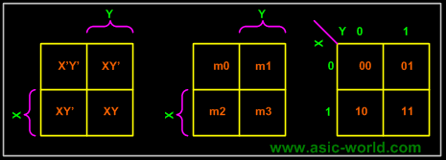

Equivalent labeling
K-map needs not follow the ordering as shown in the figure above. What this means is that we can change the position of m0, m1, m2, m3 of the above figure as shown in the two figures below.
Position assignment is the same as the default k-maps positions. This is the one which we will be using throughout this tutorial.

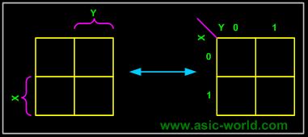

This figure is with changed position of m0, m1, m2, m3.

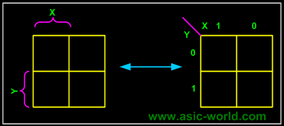

The K-map for a function is specified by putting a '1' in the square corresponding to a minterm, a '0' otherwise.

Example- Carry and Sum of a half adder

In this example we have the truth table as input, and we have two output functions. Generally we may have n output functions for m input variables. Since we have two output functions, we need to draw two k-maps (i.e. one for each function). Truth table of 1 bit adder is shown below. Draw the k-map for Carry and Sum as shown below.

X | Y | Sum | Carry
0 | 0 | 0 | 0
0 | 1 | 1 | 0
1 | 0 | 1 | 0
1 | 1 | 0 | 1

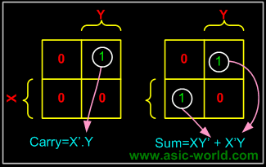

Grouping/Circling K-maps
The power of K-maps is in minimizing the terms, K-maps can be minimized with the help of grouping the terms to form single terms. When forming groups of squares, observe/consider the following:
- Every square containing 1 must be considered at least once.
- A square containing 1 can be included in as many groups as desired.
- A group must be as large as possible.
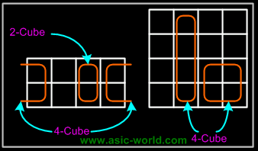
- If a square containing 1 cannot be placed in a group, then leave it out to include in final expression.
- The number of squares in a group must be equal to 2
- , i.e. 2,4,8,.
- The map is considered to be folded or spherical, therefore squares at the end of a row or column are treated as adjacent squares.
- The simplified logic expression obtained from a K-map is not always unique. Groupings can be made in different ways.
- Before drawing a K-map the logic expression must be in canonical form.
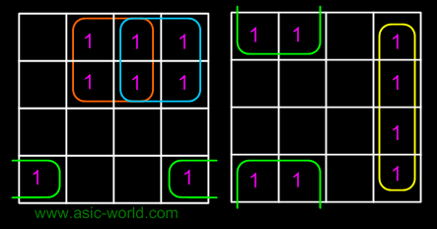

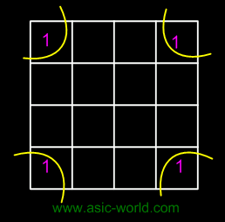

In the next few pages we will see some examples on grouping

Example of invalid groups

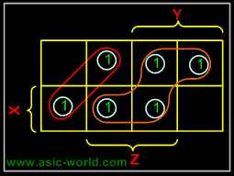

Example - X'Y+XY
In this example we have the equation as input, and we have one output function. Draw the k-map for function F with marking 1 for X'Y and XY position. Now combine two 1's as shown in figure to form the single term. As you can see X and X' get canceled and only Y remains. F = Y

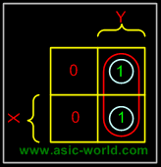

Example - X'Y+XY+XY'
In this example we have the equation as input, and we have one output function. Draw the k-map for function F with marking 1 for X'Y, XY and XY position. Now combine two 1's as shown in figure to form the two single terms.F = X + Y
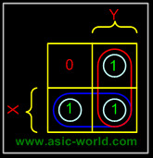
3-Variable K-Map
There are 8 minterms for 3 variables (X, Y, Z). Therefore, there are 8 cells in a 3-variable K-map. One important thing to note is that K-maps follow the gray code sequence, not the binary one.

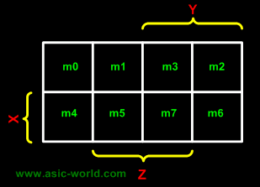

Using gray code arrangement ensures that minterms of adjacent cells differ by only ONE literal. (Other arrangements which satisfy this criterion may also be used.)
Each cell in a 3-variable K-map has 3 adjacent neighbours. In general, each cell in an n-variable K-map has n adjacent neighbours.

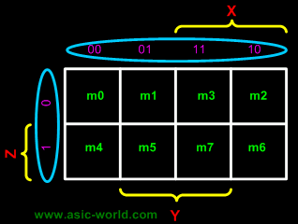

There is wrap-around in the K-map
- X'Y'Z' (m0) is adjacent to X'YZ' (m2)
- XY'Z' (m4) is adjacent to XYZ' (m6)

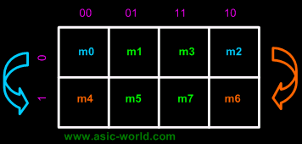

Example

F = XYZ'+XYZ+X'YZ

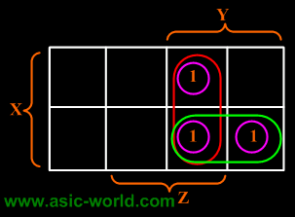

F = XY + YZ

Example
F(X,Y,Z) = (1,3,4,5,6,7)

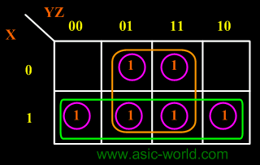

F = X + Z

4-Variable K-Map

There are 16 cells in a 4-variable (W, X, Y, Z); K-map as shown in the figure below.

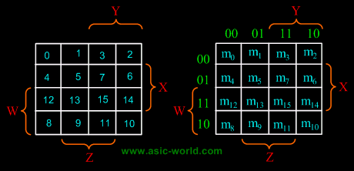

There are 2 wrap-around: a horizontal wrap-around and a vertical wrap-around. Every cell thus has 4 neighbours. For example, the cell corresponding to minterm m0 has neighbours m1, m2, m4 and m8.

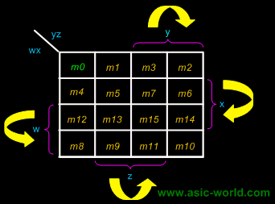

Example
F(W,X,Y,Z) = (1,5,12,13)

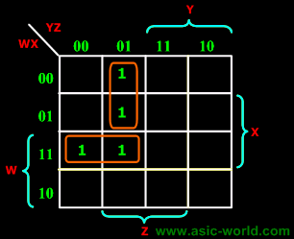

F = WY'Z + W'Y'Z

Example
F(W,X,Y,Z) = (4, 5, 10, 11, 14, 15)

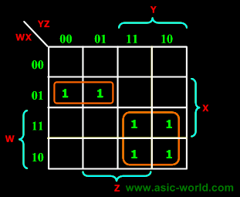

F = W'XY' + WY

5-Variable K-Map

There are 32 cells in a 5-variable (V, W, X, Y, Z); K-map as shown in the figure below.

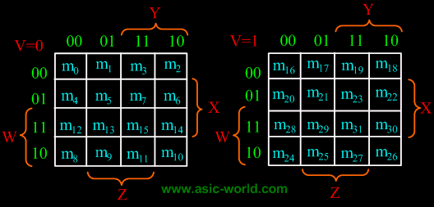

Inverse Function
- The 0's on a K-map indicate when the function is 0.
- We can minimize the inverse function by grouping the 0's (and any suitable don't cares) instead of the 1's.
- This technique leads to an expression which is not logically equivalent to that obtained by grouping the 1's (i.e., the inverse of X != X').
- Minimizing for the inverse function may be particularly advantageous if there are many more 0's than 1's on the map.
  - We can also apply De Morgan's theorem to obtain a product-of-sum expression.

QUINE-McCLUSKEY MINIMIZATION

Quine-McCluskey minimization method uses the same theorem to produce the solution as the K-map method, namely X(Y+Y')=X

Minimization Technique
- The expression is represented in the canonical SOP form if not already in that form.
- The function is converted into numeric notation.
- The numbers are converted into binary form.
- The minterms are arranged in a column divided into groups.
- Begin with the minimization procedure.
  - Each minterm of one group is compared with each minterm in the group immediately below.
  - Each time a number is found in one group which is the same as a number in the group below except for one digit, the numbers pair is ticked and a new composite is created.
  - This composite number has the same number of digits as the numbers in the pair except the digit different which is replaced by an "x".
- The above procedure is repeated on the second column to generate a third column.
- The next step is to identify the essential prime implicants, which can be done using a prime implicant chart.
  - Where a prime implicant covers a minterm, the intersection of the corresponding row and column is marked with a cross.
  - Those columns with only one cross identify the essential prime implicants. -> These prime implicants must be in the final answer.
  - The single crosses on a column are circled and all the crosses on the same row are also circled, indicating that these crosses are covered by the prime implicants selected.
  - Once one cross on a column is circled, all the crosses on that column can be circled since the minterm is now covered.
  - If any non-essential prime implicant has all its crosses circled, the prime implicant is redundant and need not be considered further.
- Next, a selection must be made from the remaining nonessential prime implicants, by considering how the non-circled crosses can be covered best.
  - One generally would take those prime implicants which cover the greatest number of crosses on their row.
  - If all the crosses in one row also occur on another row which includes further crosses, then the latter is said to dominate the former and can be selected.
  - The dominated prime implicant can then be deleted.

Example
Find the minimal sum of products for the Boolean expression, f=(1,2,3,7,8,9,10,11,14,15), using Quine-McCluskey method.
Firstly these minterms are represented in the binary form as shown in the table below. The above binary representations are grouped into a number of sections in terms of the number of 1's as shown in the table below.
Binary representation of minterms

Minterms | U | V | W | X
1 | 0 | 0 | 0 | 1
2 | 0 | 0 | 1 | 0
3 | 0 | 0 | 1 | 1
7 | 0 | 1 | 1 | 1
8 | 1 | 0 | 0 | 0
9 | 1 | 0 | 0 | 1
10 | 1 | 0 | 1 | 0
11 | 1 | 0 | 1 | 1
14 | 1 | 1 | 1 | 0
15 | 1 | 1 | 1 | 1

Group of minterms for different number of 1's

No of 1's | Minterms | U | V | W | X
1 | 1 | 0 | 0 | 0 | 1
1 | 2 | 0 | 0 | 1 | 0
1 | 8 | 1 | 0 | 0 | 0
2 | 3 | 0 | 0 | 1 | 1
2 | 9 | 1 | 0 | 0 | 1
2 | 10 | 1 | 0 | 1 | 0
3 | 7 | 0 | 1 | 1 | 1
3 | 11 | 1 | 0 | 1 | 1
3 | 14 | 1 | 1 | 1 | 0
4 | 15 | 1 | 1 | 1 | 1

Any two numbers in these groups which differ from each other by only one variable can be chosen and combined, to get 2-cell combination, as shown in the table below.

2-Cell combinations

Combinations | U | V | W | X
(1,3) | 0 | 0 | - | 1
(1,9) | - | 0 | 0 | 1
(2,3) | 0 | 0 | 1 | -
(2,10) | - | 0 | 1 | 0
(8,9) | 1 | 0 | 0 | -
(8,10) | 1 | 0 | - | 0
(3,7) | 0 | - | 1 | 1
(3,11) | - | 0 | 1 | 1
(9,11) | 1 | 0 | - | 1
(10,11) | 1 | 0 | 1 | -
(10,14) | 1 | - | 1 | 0
(7,15) | - | 1 | 1 | 1
(11,15) | 1 | - | 1 | 1
(14,15) | 1 | 1 | 1 | -

From the 2-cell combinations, one variable and dash in the same position can be combined to form 4-cell combinations as shown in the figure below.

4-Cell combinations

Combinations | U | V | W | X
(1,3,9,11) | - | 0 | - | 1
(2,3,10,11) | - | 0 | 1 | -
(8,9,10,11) | 1 | 0 | - | -
(3,7,11,15) | - | - | 1 | 1
(10,11,14,15) | 1 | - | 1 | -

The cells (1,3) and (9,11) form the same 4-cell combination as the cells (1,9) and (3,11). The order in which the cells are placed in a combination does not have any effect. Thus the (1,3,9,11) combination could be written as (1,9,3,11).
From above 4-cell combination table, the prime implicants table can be plotted as shown in table below.

Prime Implicants Table

Prime Implicants | 1 | 2 | 3 | 7 | 8 | 9 | 10 | 11 | 14 | 15
(1,3,9,11) | X | - | X | - | - | X | - | X | - | -
(2,3,10,11) | - | X | X | - | - | - | X | X | - | -
(8,9,10,11) | - | - | - | - | X | X | X | X | - | -
(3,7,11,15) | - | - | - | - | - | - | X | X | X | X
- | X | X | - | X | X | - | - | - | X | -

The columns having only one cross mark correspond to essential prime implicants. A yellow cross is used against every essential prime implicant. The prime implicants sum gives the function in its minimal SOP form.
Y = V'X + V'W + UV' + WX + UW

Digital Combinational Logic

- Introduction
- Decoders
  - Basic Binary Decoder
  - Binary n-to-2n Decoders
  - Example - 2-to-4 Binary Decoder
  - Example - 3-to-8 Binary Decoder
  - Implementing Functions Using Decoders
  - Example - Full adder

- Encoders
  - Example - Octal-to-Binary Encoder
  - Example - Decimal-to-Binary Encoder
- Priority Encoder
  - Example - 4to3 Priority Encoder
- Multiplexer
  - Mechanical Equivalent of a Multiplexer
  - Example - 2x1 MUX
  - Design of a 2:1 Mux
  - Example : 4:1 MUX
  - Larger Multiplexers
  - Example - 8-to-1 multiplexer from Smaller MUX
  - Example - 16-to-1 multiplexer from 4:1 mux
- De-multiplexers
  - Mechanical Equivalent of a De-Multiplexer
  - Example: 1-to-4 De-multiplexer
- Boolean Function Implementation
  - Implementing Functions Multiplexers
  - Example: 3-variable Function Using 8-to-1 mux
  - Example: 3-variable Function Using 4-to-1 mux
  - Example: 2 to 4 Decoder using Demux
- Mux-Demux Application Example

Introduction

Combinatorial Circuits are circuits which can be considered to have the following generic structure.

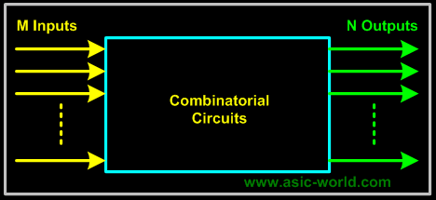

Whenever the same set of inputs is fed in to a combinatorial circuit, the same outputs will be generated. Such circuits are said to be stateless. Some simple combinational logic elements that we have seen in previous sections are "Gates".

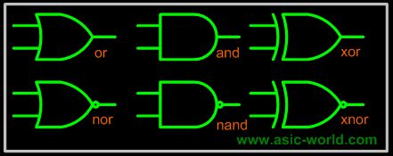

All the gates in the above figure have 2 inputs and one output; combinational elements simplest form are "not" gate and "buffer" as shown in the figure below. They have only one input and one output.

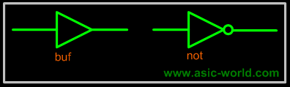

Decoders
A decoder is a multiple-input, multiple-output logic circuit that converts coded inputs into coded outputs, where the input and output codes are different; e.g. n-to-2n, BCD decoders.
Enable inputs must be on for the decoder to function, otherwise its outputs assume a single "disabled" output code word.
Decoding is necessary in applications such as data multiplexing, 7 segment display and memory address decoding. Figure below shows the pseudo block of a decoder.

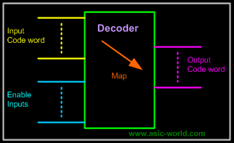

Basic Binary Decoder
And AND gate can be used as the basic decoding element, because its output is HIGH only when all its inputs are HIGH. For example, if the input binary number is 0110, then, to make all the inputs to the AND gate HIGH, the two outer bits must be inverted using two inverters as shown in figure below.

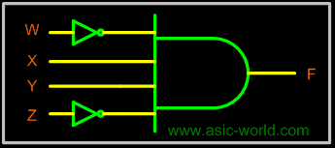

Binary n-to-2^{n} Decoders

A binary decoder has n inputs and 2^{n} outputs. Only one output is active at any one time, corresponding to the input value. Figure below shows a representation of Binary n-to-2^{n} decoder

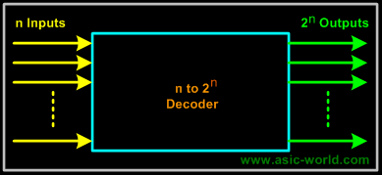

Encoders

An encoder is a combinational circuit that performs the inverse operation of a decoder. If a device output code has fewer bits than the input code has, the device is usually called an encoder. e.g. 2^{n}-to-n, priority encoders.
The simplest encoder is a 2^{n}-to-n binary encoder, where it has only one of 2^{n}inputs = 1 and the output is the n-bit binary number corresponding to the active input.

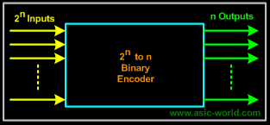
Example - Octal-to-Binary Encoder

Octal-to-Binary take 8 inputs and provides 3 outputs, thus doing the opposite of what the 3-to-8 decoder does. At any one time, only one input line has a value of 1. The figure below shows the truth table of an Octal-to-binary encoder.

Truth Table

I0 | I1 | I2 | I3 | I4 | I5 | I6 | I7 | Y2 | Y1 | Y0
1 | 0 | 0 | 0 | 0 | 0 | 0 | 0 | 0 | 0 | 0
0 | 1 | 0 | 0 | 0 | 0 | 0 | 0 | 0 | 0 | 1
0 | 0 | 1 | 0 | 0 | 0 | 0 | 0 | 0 | 1 | 0
0 | 0 | 0 | 1 | 0 | 0 | 0 | 0 | 0 | 1 | 1
0 | 0 | 0 | 0 | 1 | 0 | 0 | 0 | 1 | 0 | 0
0 | 0 | 0 | 0 | 0 | 1 | 0 | 0 | 1 | 0 | 1
0 | 0 | 0 | 0 | 0 | 0 | 1 | 0 | 1 | 1 | 0
0 | 0 | 0 | 0 | 0 | 0 | 0 | 1 | 1 | 1 | 1

For an 8-to-3 binary encoder with inputs I0-I7 the logic expressions of the outputs Y0-Y2 are:

Y0 = I1 + I3 + I5 + I7
Y1= I2 + I3 + I6 + I7
Y2 = I4 + I5 + I6 +I7

Based on the above equations, we can draw the circuit as shown below

Circuit

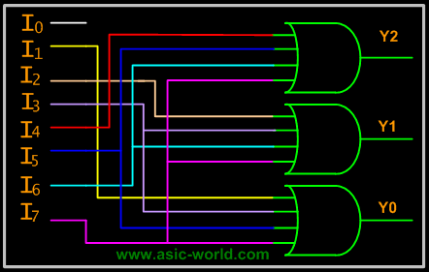

A multiplexer (MUX) is a digital switch which connects data from one of n sources to the output. A number of select inputs determine which data source is connected to the output. The block diagram of MUX with n data sources of b bits wide and s bits wide select line is shown in below figure.

MUX acts like a digitally controlled multi-position switch where the binary code applied to the select inputs controls the input source that will be switched on to the output as shown in the figure below. At any given point of time only one input gets selected and is connected to output, based on the select input signal.

Mechanical Equivalent of a Multiplexer
The operation of a multiplexer can be better explained using a mechanical switch as shown in the figure below. This rotary switch can touch any of the inputs, which is connected to the output. As you can see at any given point of time only one input gets transferred to output.

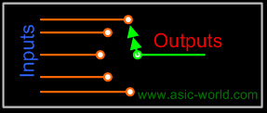

Example - 2x1 MUX
A 2 to 1 line multiplexer is shown in figure below, each 2 input lines A to B is applied to one input of an AND gate. Selection lines S are decoded to select a particular AND gate. The truth table for the 2:1 mux is given in the table below.

Symbol

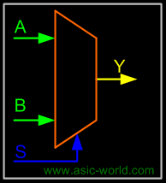

Truth Table

S | Y
0 | A
1 | B

To derive the gate level implementation of 2:1 mux we need to have truth table as shown in figure. And once we have the truth table, we can draw the K-map as shown in figure for all the cases when Y is equal to '1'.

Combining the two 1' as shown in figure, we can drive the output y as shown below

Y = A.S' + B.S

Truth Table

B | A | S | Y
0 | 0 | 0 | 0
0 | 0 | 1 | 0
0 | 1 | 0 | 1
0 | 1 | 1 | 0
1 | 0 | 0 | 0
1 | 0 | 1 | 1
1 | 1 | 0 | 1
1 | 1 | 1 | 1

Kmap

Circuit

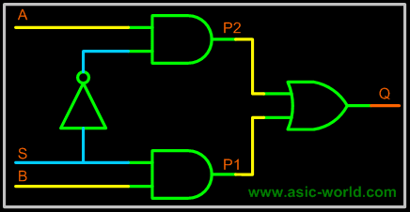

Example : 4:1 MUX
A 4 to 1 line multiplexer is shown in figure below, each of 4 input lines I0 to I3 is applied to one input of an AND gate. Selection lines S0 and S1 are decoded to select a particular AND gate. The truth table for the 4:1 mux is given in the table below.

Symbol

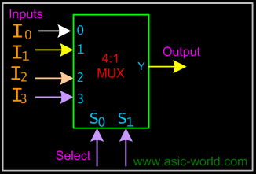

Truth Table

S1 | S0 | Y
0 | 0 | I0
0 | 1 | I1
1 | 0 | I2
1 | 1 | I3

Circuit
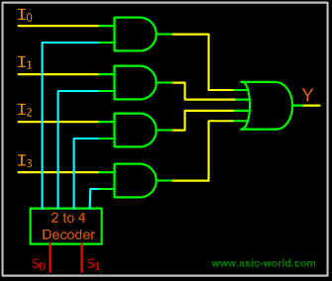
Larger Multiplexers

Larger multiplexers can be constructed from smaller ones. An 8-to-1 multiplexer can be constructed from smaller multiplexers as shown below.

Example - 8-to-1 multiplexer from Smaller MUX

Truth Table

S2 | S1 | S0 | F
0 | 0 | 0 | I0
0 | 0 | 1 | I1
0 | 1 | 0 | I2
0 | 1 | 1 | I3
1 | 0 | 0 | I4
1 | 0 | 1 | I5
1 | 1 | 0 | I6
1 | 1 | 1 | I7

Circuit

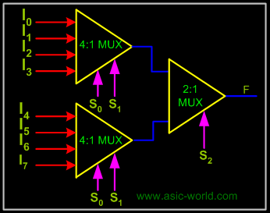

Example - 16-to-1 multiplexer from 4:1 mux

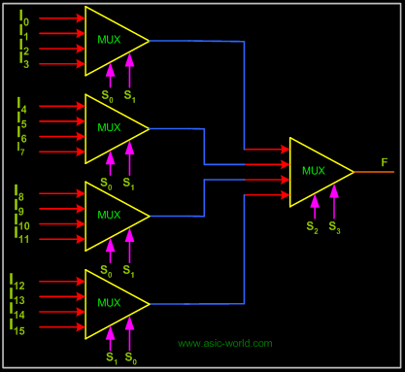

They are digital switches which connect data from one input source to one of n outputs.
Usually implemented by using n-to-2^{n} binary decoders where the decoder enable line is used for data input of the de-multiplexer.
The figure below shows a de-multiplexer block diagram which has got s-bits-wide select input, one b-bits-wide data input and n b-bits-wide outputs.
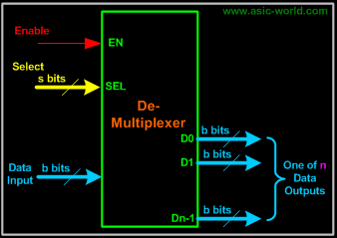

The operation of a de-multiplexer can be better explained using a mechanical switch as shown in the figure below. This rotary switch can touch any of the outputs, which is connected to the input. As you can see at any given point of time only one output gets connected to input.

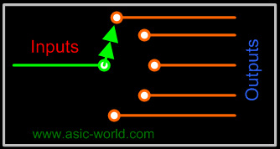

1-bit 4-output de-multiplexer using a 2x4 binary decoder.

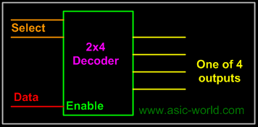

Example: 1-to-4 De-multiplexer

Symbol

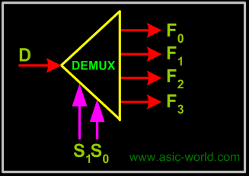

Truth Table

S1 | S0 | F0 | F1 | F2 | F3
0 | 0 | D | 0 | 0 | 0
0 | 1 | 0 | D | 0 | 0
1 | 0 | 0 | 0 | D | 0
1 | 1 | 0 | 0 | 0 | D

Earlier we had seen that it is possible to implement Boolean functions using decoders. In the same way it is also possible to implement Boolean functions using muxers and de-muxers.

Implementing Functions Multiplexers

Any n-variable logic function can be implemented using a smaller 2^{n-1}-to-1 multiplexer and a single inverter (e.g 4-to-1 mux to implement 3 variable functions) as follows.
Express function in canonical sum-of-minterms form. Choose n-1 variables as inputs to mux select lines. Construct the truth table for the function, but grouping inputs by selection line values (i.e select lines as most significant inputs).
Determine multiplexer input line i values by comparing the remaining input variable and the function F for the corresponding selection lines value i.

We have four possible mux input line i values:

- Connect to 0 if the function is 0 for both values of remaining variable.
- Connect to 1 if the function is 1 for both values of remaining variable.
- Connect to remaining variable if function is equal to the remaining variable.
- Connect to the inverted remaining variable if the function is equal to the remaining variable inverted.

